
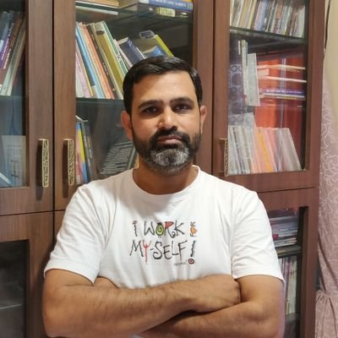
Prasad Ramachandra Namjoshi Ph.D.

Writer | Director | Producer | Teacher | Academician
Director of Abhishikta Infotainments Pvt. Ltd. (since 2004) – a media production house dedicated to produce short films, documentaries, corporate films, ad films, feature films and educational videos.

Filmography: feature films

Educational Qualification
Ph.D. in Mass Media
Master of Communication Studies (Video Production)
Post Graduate Diploma in Journalism
B.Sc.
B.A. (Additional, in English Literature)
Qualified State Eligibility Test for Lectureship (SET) Journalism and Mass Communication

Contact:
Mobile: +91 94225 14724
Email: prasadnamjoshi@gmail.com

Web:
www.prasadnamjoshi.com
www.abhishikta.co.in
YouTube Channel ShortCut
https://www.youtube.com/channel/UC0g9UvtPDk0Kqi0hogxEF4A
LinkedIn:
https://in.linkedin.com/in/prasad-namjoshi-488a6317

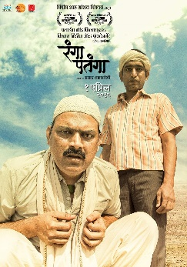 | Rangaa Patangaa | Writer and Director  Awards  Best Director & Best Film Sant Tukaram Award @ Pune International FF 2016  Best Director & Best Film @ 53rd Maharashtra State Award  Best Debut Director @ Sanskruti Kala Darpan Awards, 2016  Best Director & Best Screenplay @ Chitrapadarpan Awards 2017
Nominations | Best Debut Director @ 53rd Maharashtra State Awards | Best Director, Best Dialogues and Best Film @ Sanskruti Kala Darpan Awards 2016
Official Selections | Mumbai International FF 2014 | 16th River to River Florence Indian FF, Italy 2016 | NCPA’s Nave Valan Marathi FF Mumbai 2016 | Aurangabad International FF 2016 | Goa Marathi FF 2016 | Dadasaheb Phalke FF New Delhi 2016
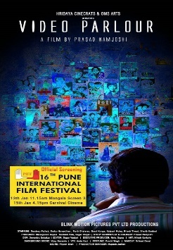 | Video Parlour | Writer and Director  Official Selections  Pune International FF 2018  Singapore South Asian International FF 2018  Bengaluru International FF 2018  Orange City International FF 2018  Goa Marathi FF 2019
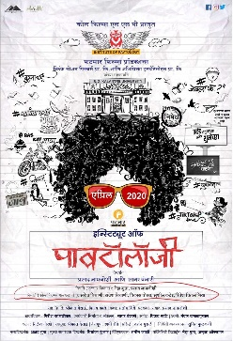 | Institute of Pavtollogy | Writer, Director, Producer AND Lyrisist  Official Selection  Pune International FF 2020  Yashwant International FF 2020
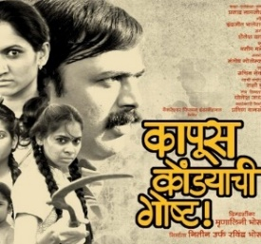 | KAPUSKONDYACHI GOSHTA | STORY, SCREENPLAY AND DIALOGUES  Awards | Best Story @ Mumbai Woman’s International FF 2014  Nominations | Best Story at Sahyadri Cine Awards 2014 | Screened and awarded at more than 35 national and international film festivals Shortlisted in last 323 films in Oscar competition 2015

PhotoPrem | dialogues
Official selection MAMI2019, IFFI2019, PIFF2020
Nomination Best Dialogue at Filmfare 2022

Sumi | screenplay, dialogues and lyrics
National Award as Best Children Film at 68th National Awards
Nomination Best Lyrics Mata Sanman 2023

Highwaytouch Gunthamantri | story, screenplay and dialogues
Coming soon
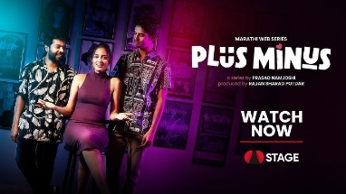 | WEB series  Plus Minus (6 EPISODES/20 MIN) | WRITER & DIRECTOR  A mini RomCom series on the life of Gen Zee on STAGE OTT

Short Films
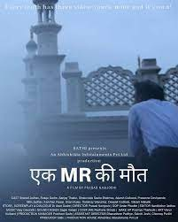 | Ek MR Ki Maut (2019/25 min) | Director & Producer  Official selection | 10th Pune SFF 2020 with Best Actor Award | 3rd South Asian FF Kolkata 2019 | 6th Goa SFF 2019 | Lift off seasons April 2020 UK | 9th Aarogya SFF Pune 2019| 3rd ASIFF Pune 2019 | 4th National SFF Indapur 2020 | Ankur FF Nasik 2019 | The Empty Space FF 2020  Official screenings | COPASAH Global Symposium, New Delhi 2020 | Press Club of India, New Delhi 2019
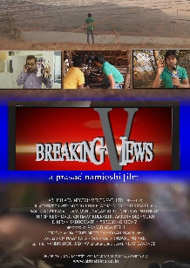 | Breaking Views (2012/14 min) | Writer, director & producer  Awards  Second Best Film @ ICE Short Film Festival 2016  Best Director @ My Mumbai Short Film Festival 2015  Official selection | Lakecity International SFF, Bhopal with Nomination for Special Jury Award 2015 | 9th Adda SFF Assam 2015 | 2nd Imphal IFF Manipur 2015 | Pune SFF | SeamEdu SFF | Maitri SFF Pune | RAIT film festival, Mumbai | 1st Smita Patil Film Festival, Pune 2015

Racelessness (2008/16 min) | Writer, director & producer
Nominaton | Best film & Best Director @ 2nd Hyderabad International Film Festival 2008
Official Selection | Jaipur International FF 2008 | Shot too Short FF Pune 2008 | RAIT FF Mumbai with Special Jury award for Best Actor 2008 | Prabhat Film Society, Mumbai 2008

Kaanch ke Bartan (2006/6 min) | Writer ANd Director
Award | 2nd Best Film award at NCERT youth film competition 2010.
Official selection | ICE short film festival 2011

Documentaries
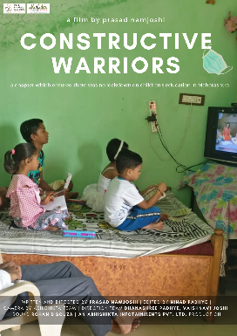 | constructive Warriors (2021/10min) | writer, director & producer  a documentary on educational efforts taken in global pandemic.  Shaaradeeya (27 min) | Writer, director & producer  portrait of Pt. Sharad Gokhale, a singer performer of Marathi Musical Theatrical.  Awarded 2nd Best Film @ Shot too Short Film Festival, Pune.  Prakaashvaat (17min) | writer, director & producer  Autism awareness documentary for Prasanna Autism Centre, Pune.

Swami Vidnyananand (15 min) | writer, director & producer
Manashakti- The New Way (23 min) | writer, director & producer
Documentaries for Manashakti Research Center, Lonawala in English & Marathi.
Makarsankrant (25 min) | writer, director & producer
Documentary in English on Indian Sankranti Festival for project Bhasha Mandakini for Central Institute of Indian Languages, Mysore, India

Maharashtra Art & Craft Paithani (25 min) | writer, director & producer
Documentary in English on traditional Paithani saree for the project Bhasha Mandakini for Central Institute of Indian Languages, Mysore, India

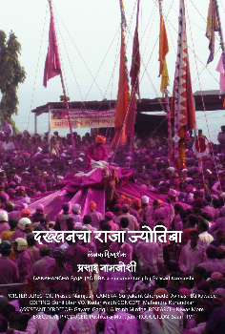
Rahgeer (52 min) | writer, director & producer
A life portrait of a self-made industrialist for Laboratory Suppliers, Mumbai

A documentary (30 min): | writer, director & producer
For Department for Health, NMMC

Dakhhancha Raja Jyotiba (40 MIN) | writer and director
A documentary on Jyotiba Festival for Saam TV Marathi
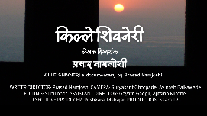 | Kille Shivaneri (40 MIN) | writer and director  A documentary portraying fort Shivaneri for Saam TV Marathi
Health line: Miraj-Kolhapur (50 min) | writer and director
Health line: Marathwada (50 min) | writer and director
Documentaries portraying health services of the said regions for Saam TV Marathi

Television series
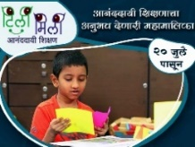 | Tilimili (480 episodes/25 min/2020) | writer, director & producer  Educational video series for school children who were kept away from education due to global pandemic. Total 480 episodes telecast on DD Sahyadri, in a record 10 weeks’ time.

Turning Point (13 episodes/25 mins/2018) | writer, director & producer
An educational TV serial in Hindi for DD Bihar and ETV Bihar.
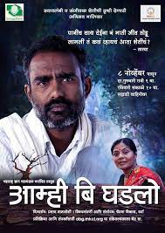 | Amhi Bighadalo (26 episodes /25 mins/2018) | writer, director & producer  A TV serial in Marathi for DD Sahyadri, based on self-sustainable farming by Chetana Vikas, Wardha  Ferfatka (7 EPISODEs/25 mins) | writer, director  Weekly travel show for Saam TV Marathi  Young Buzz (13 EPISODES/25 mins) | writer, director | Weekly Anchor Show for Saam TV Marathi

Campus (36 episodes/25 min) |writer, director | Road Show in Hindi for E-TV Bihar

Pune Diwali Festival (12 episodes/25 min) | writer, director | For Saam TV

Ha Khel Sanchitacha (90 episodes/25 mins) | screenplay and dialogues |
Daily serial on ETV Marathi
Jeevansangeet (100 min) & Jave Kavitechya Gava (70 min) | director
Multi camera music programs for Saam TV Marathi

Educational Videos
Hobby Home (41 episodes/6 min) | Writer, director & producer Education video series for children for Grammangal
SKILL BASED LEARNING (600 episodes/2 min) | WRITER, DIRECTOR & PRODUCER |
600+ videos in English, Hindi, Marathi

Taarunyabhaan | director | Sex Education video series by Dr. Rani Bang for SEARCH

CHW-Asha | writer, director & producer | Series on community health workers for
Dr. Abhay Bang, SEARCH, Gadhchiroli and MKCL, Pune

Science experiments (21 episodes/6 min) | director and producer |
For Std X students PPK program for MKCL, Pune.

Corporate films
More than 100 corporate films as a writer, director & producer for esteemed clients like MKCL; Syngenta India Ltd; Baliraja; Mind Tree; Pune Police; Laboratory Suppliers, Mumbai; Parth Knowledge Network, Mumbai; Paranjpe Schemes Ltd; SEARCH Gadhchiroli; Grammangal etc.

As a Program Executive
At E-TV Marathi, handled prime time serials as an Executive Producer during 2002-04.

Workshops
Conducted workshops on Film Making, Script Writing, Direction, Film appreciation, Media Awareness for students and faculties of different institutes and corporate firms.

Publications: As a columnist
Title of the column  Bond Girls are Forever | Genre  Non-fiction, bond girls’ biography | Publication  Saptahik Sakal
Chittarkatha | Non-fiction, making of cinema | Daily Punyanagari
Laghuttam Saadharan | Non-fiction, History of Short Films | Daily Maharashtra Times
Ticha Cinema | Non-fiction, female protagonists of international cinema | Daily Maharashtra Times
Nautanki | Fiction satire on theatre activity | Menaka magazine
Navtak | Fiction satire poetry | Menaka magazine
Thode Hasu Thode Sosu | Fiction satire on society | Menaka magazine
Anganapalikadche | Fiction satire on international cinema | Tarangan magazine.
Champochi Goshta | Fiction series on film industry | Daily Lokmat
Cut Away | Fiction satire on film industry | Premier magazine
Junglewood | Fiction satire | Premier magazine
Blogam Blog | Fiction satire blog | www.fillambazi.com
Glorious 50 | Critical review on classic Marathi Cinema | www.fillambazi.com
Zoom In | Non-fiction, Novel to Cinema | Ityadi magazine
Point of View | Non-fiction, female protagonists of international cinema | Daily Sakal
ShortCUT | Non-fiction, classic short films | Daily Sakal
Filmology | Non-fiction, classic films | Daily Sakal
Wide Angle | Non-fiction, economy of media world | Arthamanthan biweekly

PUBLIcations | Books
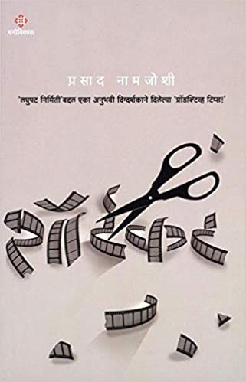 | Shortcut  Awarded with  Maharashtra State Government Literary Award 2013  Manovikas Prakashan  (4th edition)  ISBN 9789382468417 | 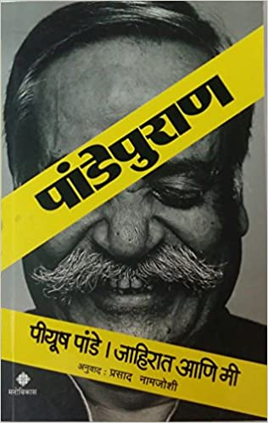 | Pandepuran  a translation in Marathi of Pandeymonium by ad guru Piyush Pandey.  2017  Manovikas Prakashan  (3rd edition)  ISBN 9789386118479
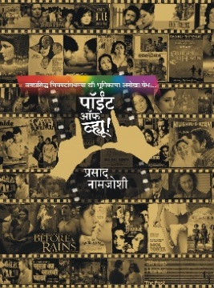 | Point of View  Analysis of female characters of international cinema.  Abhijit Prakashan 2022  (2nd edition)  ISBN 9789382261537 | 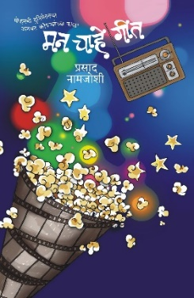 | Man Chahe Geet  Collection of short stories in Marathi  Abhijit Prakashan 2023  ISBN 978938226157
Awarded by All India Marathi Publisher's association 2022 & by
Maharashtra Sahitya Parishad for Creative Production 2023
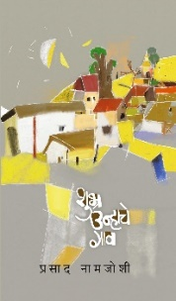 | Shubra Unhache Gav  Poetry Collection  Meera Prakashan 2025  ISBN 9788195428588 | 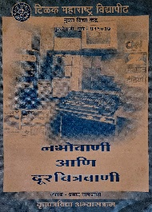 | Nabhovani Ani Doorachitravani  for students of Journalism faculty in Marathi  Tilak Maharashtra Vidyapeeth 2004

Publications | Audio Books
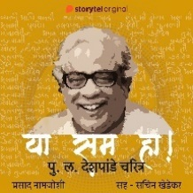 | Ya Sam Ha  Audio biography of P. L. Deshpande, veteran Marathi Writer  Published by Storytel. 2021  https://www.storytel.com/in/en/books/2229956-Ya-Sam-Ha-
Making of Classics I  Making of Classics II  https://www.storytel.com/in/en/books/615572-Making-of-Classics-S01E02 | 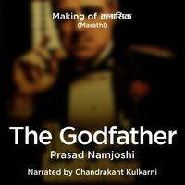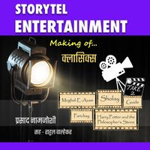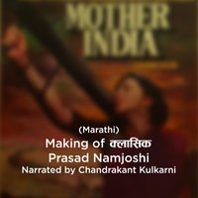  Audio books telling stories about making of classic cinema  Published by Storytel. Total 11 Episodes. 2018.

Publications: Book Chapters
Patkathakar GaDiMa. A chapter in Ga.Di.Madgulkar, Mantarlele Chaitraban published by Maharashtra Rajya Sahitya Sanskruti Mandal, Govt of Maharashtra 2020
Pulanchya Pravasvarnanaatil Akshay Navata. A chapter in Pu.La.Deshpande, Asa Asami published by Maharashtra Rajya Sahitya Sanskruti Mandal, Govt of Maharashtra 2020
Bollywood Chitrapatanchi Kotichya Koti Uddane. A chapter in Sakal Yearbook published by Sakal Papers Ltd, 2015

Publications: Articles
Published more than 600+ artiles, short stories, research articles in dailies, periodicals and Diwali special issues like Loksatta, Maharashtra Times, Lokmat, Sakal, Tarun Bharat, Samna, Saptahik Sakal, Menaka, Maher, Jatra, Akshardhara, Samvadsetu etc

YouTube channel:
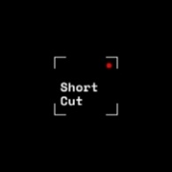 | Shortcut. An educational channel for shortfilm making for aspiring filmmakers.  https://www.youtube.com/channel/UC0g9UvtPDk0Kqi0hogxEF4A

as a teacher and Academician

Subject specialization as a VISITING faculty for 23+ years
Film Direction | Script Writing | Film Appreciation | Video Production | Mass Communication |
Visual Communication | Audio Visual Narrative | Film Studies | Storyboard Design | Film Making

Association with the Higher Education institutes:
Associate Professor & Head, School of Design and Art, DES Pune University, Pune from June 2023 to December 2025.
Visiting Professor/Guest Faculty at Dept of Media and Communication, Fergusson College, Pune | Dept. of Journalism, Savitribai Phule Pune University | Dept of Liberal Arts IDSS, SPPU I Dept of English, SPPU | Karve Stree Shikshan Sanstha, Pune | Symbiosis Centre for Media and Communications, Pune | Tilak Maharashtra Vidyapeeth | Indira Institute on Mass Communication | MMCC, Pune | DES Pune University, Pune
K. J. Somaiya College, University of Mumbai | |Ramnarain Ruia College, Matunga, Mumbai | Weigan and Lee College, Mumbai & Pune | AICAR Business School, Nerul | Framework Film and TV Institute, Pune | Symbiosis Centre for Media & Communication, Vimannagar, Pune
Dept of Journalism and Mass communication, Garware College, Pune | Symbiosis Institute of Media and Communication, Lavale, Pune | Bhartiya Vidya Bhavan, Pune | MITADT, Loni, Pune
SNDT University, Pune | Rai University, Mumbai, Pune | NFAI, Pune | Lok Shikshan Sanstha, Warora

Served as a Jury member
Pune International Film Festival, Selection Committee, 2026 | Final Jury, 57th Maharashtra State Govt Film Awards 2023 | Selection committee for Cannes Film Festival, Film Bazar 2023 for Maharashtra State Govt | Bengaluru International Short Film Festival 2022 | IEC Maha Arogya Film Festival 2022 | Annabhau Sathe International Short Film Festival | Pulotsav Short Film Festival | Weigan N Lee Short Film Competition | Ad Smith, an ad film competition by Garware College

Member, Board of Studies
Dept of Media and Communication, Fergusson College (Autonomous) Pune | Dept of Communication and Journalism, MES Abasaheb Garware College, Pune | Dept of Marathi, SP College, Pune | Dept of Marathi, Wadia College, Pune | School of Design and Art, DES PU, Pune

PhD Guide
One student has been awarded PhD, Thesis titled: ‘Creative Analysis of Song Picturization Techniques in Films Directed by Vijay Anand’

eLearning / Audio-visual content creation
Created more than 25,000 mins educational video content as a writer/director/producer.
Contributed for 2 episodes for Swayam Prabha Video Lecture Series Produced by EMMRC, Pune for CEC-UGC

Education
- Ph.D. in Mass Media, Pune (April, 2016)
Research: An Analytical Study of Change in the Television Content Appreciation Level of Indian Television Audience of Non-fiction Programs, Subject to Exposure to Alternative Television Content

- State Eligibility Test (SET), Journalism and Mass Communication, (November, 2002)
- Master of Communication Studies (MCmS) from University of Pune (May, 2001)
- PG Diploma in Journalism from University of Pune (June, 2002)
- Bachelor of Science (B.Sc.) from Nagpur University (Summer, 1998)
- BA (Additional), English Literature from Nagpur University (July, 1999)

- Academic Experience of 23+ years (Since 2003)
- Professional Work Experience of 26+ years (Since 1999)

